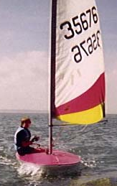
Children’s
Topper
Sailing

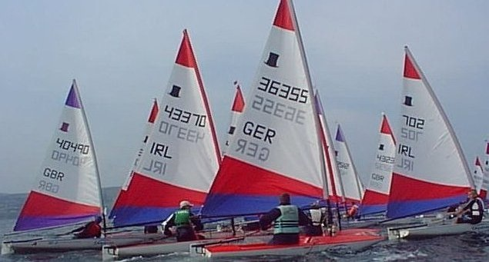

NEW
Beginners Sailing Course
Starting 17th October 2014
6 weeks
To register contact Fred Park
Email: fredngill2@yahoo.co.uk

Children aged 11 to 15 years old, must be able to swim and have own life jacket! RAHRC members.

